Here we explain the exact details of how participants kept track of the 10-second response limit in VR scenarios (for both experimental and control scenarios).

* For the burning car dilemma, participants had to respond before the car hit the ramp (shown in red circle):

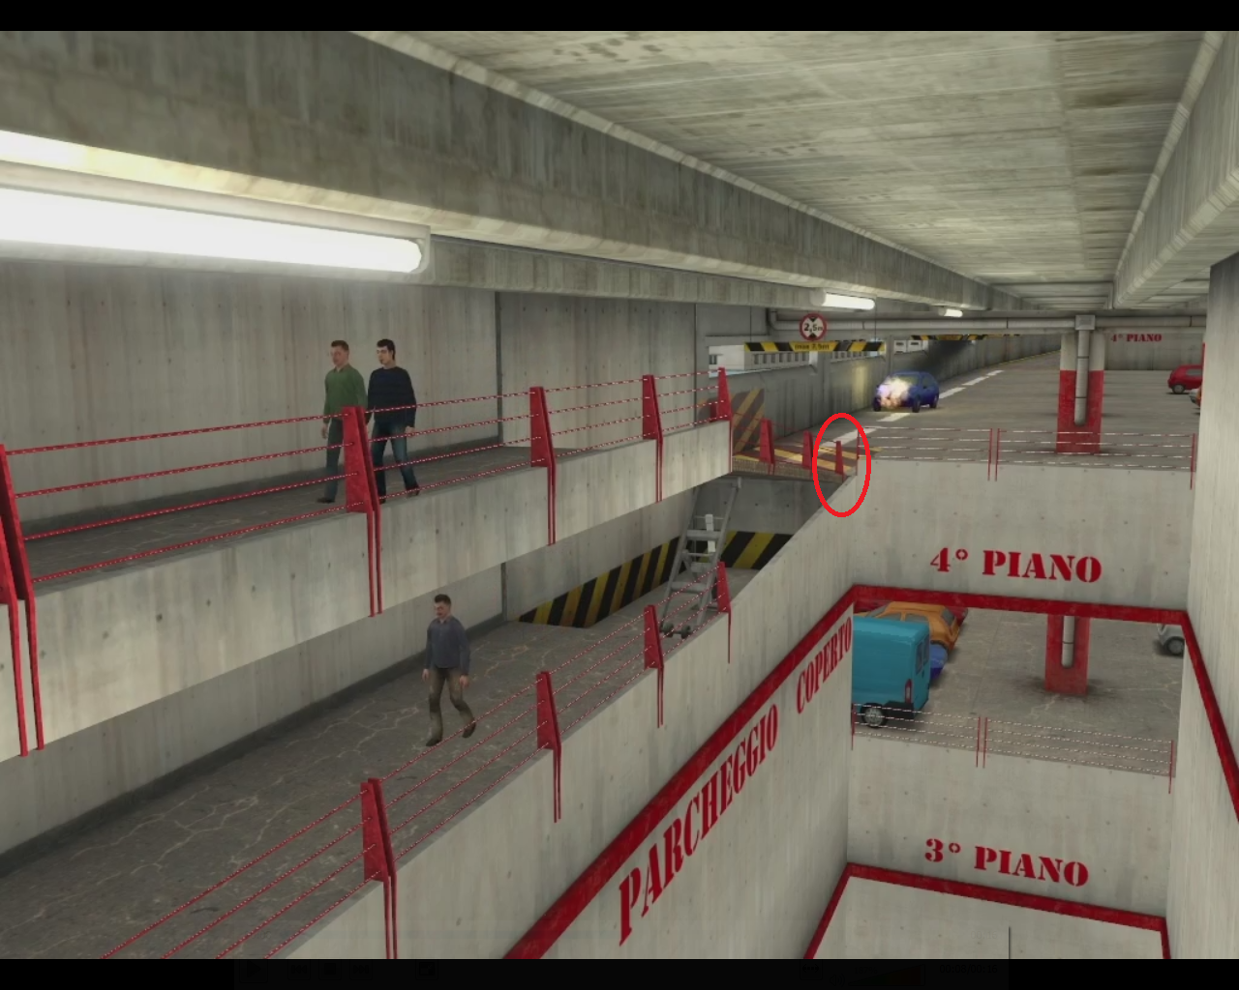

* For the lifting magnet dilemma, participants had to respond before the magnet crossed the yellow-black striped line (shown in red circle):

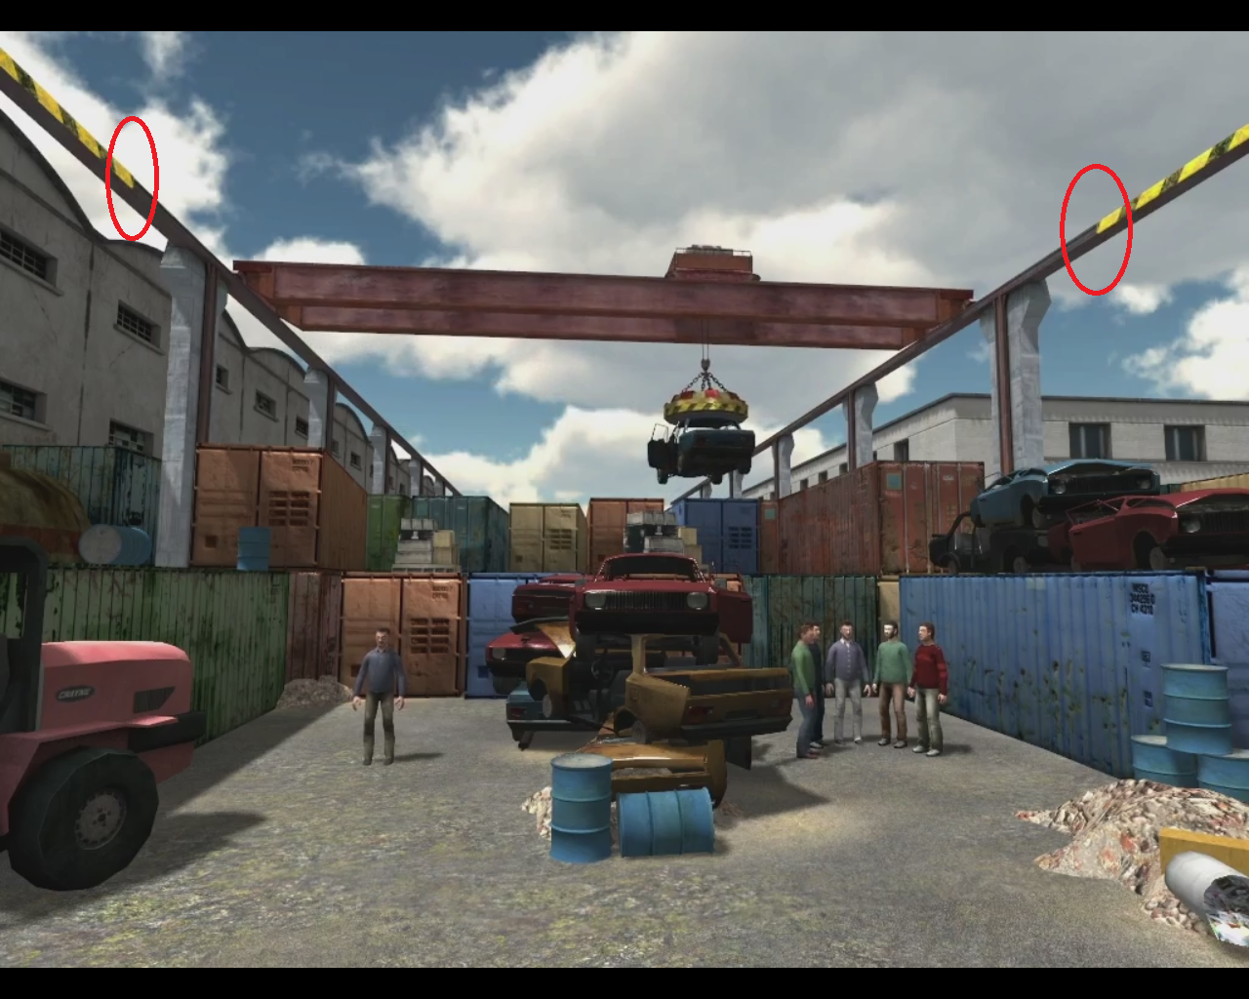

* For the pier dilemma, participants had to respond before the coast-guard boat crossed the end of the floating objects (shown in red circle):  
  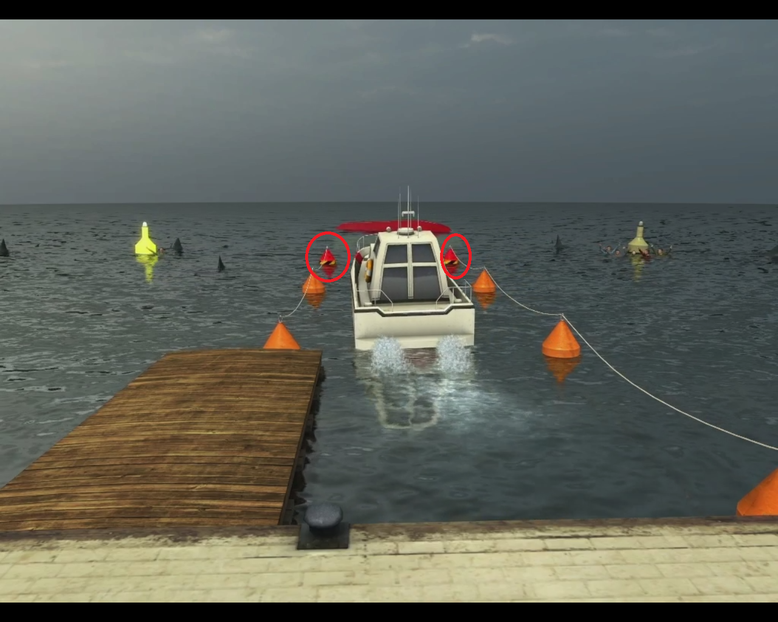
* For the train dilemma, participants had to respond before the train crossed the yellow-black striped line on the track (shown in red circle):

